Csd-340

Jessica Hall

08/12/24

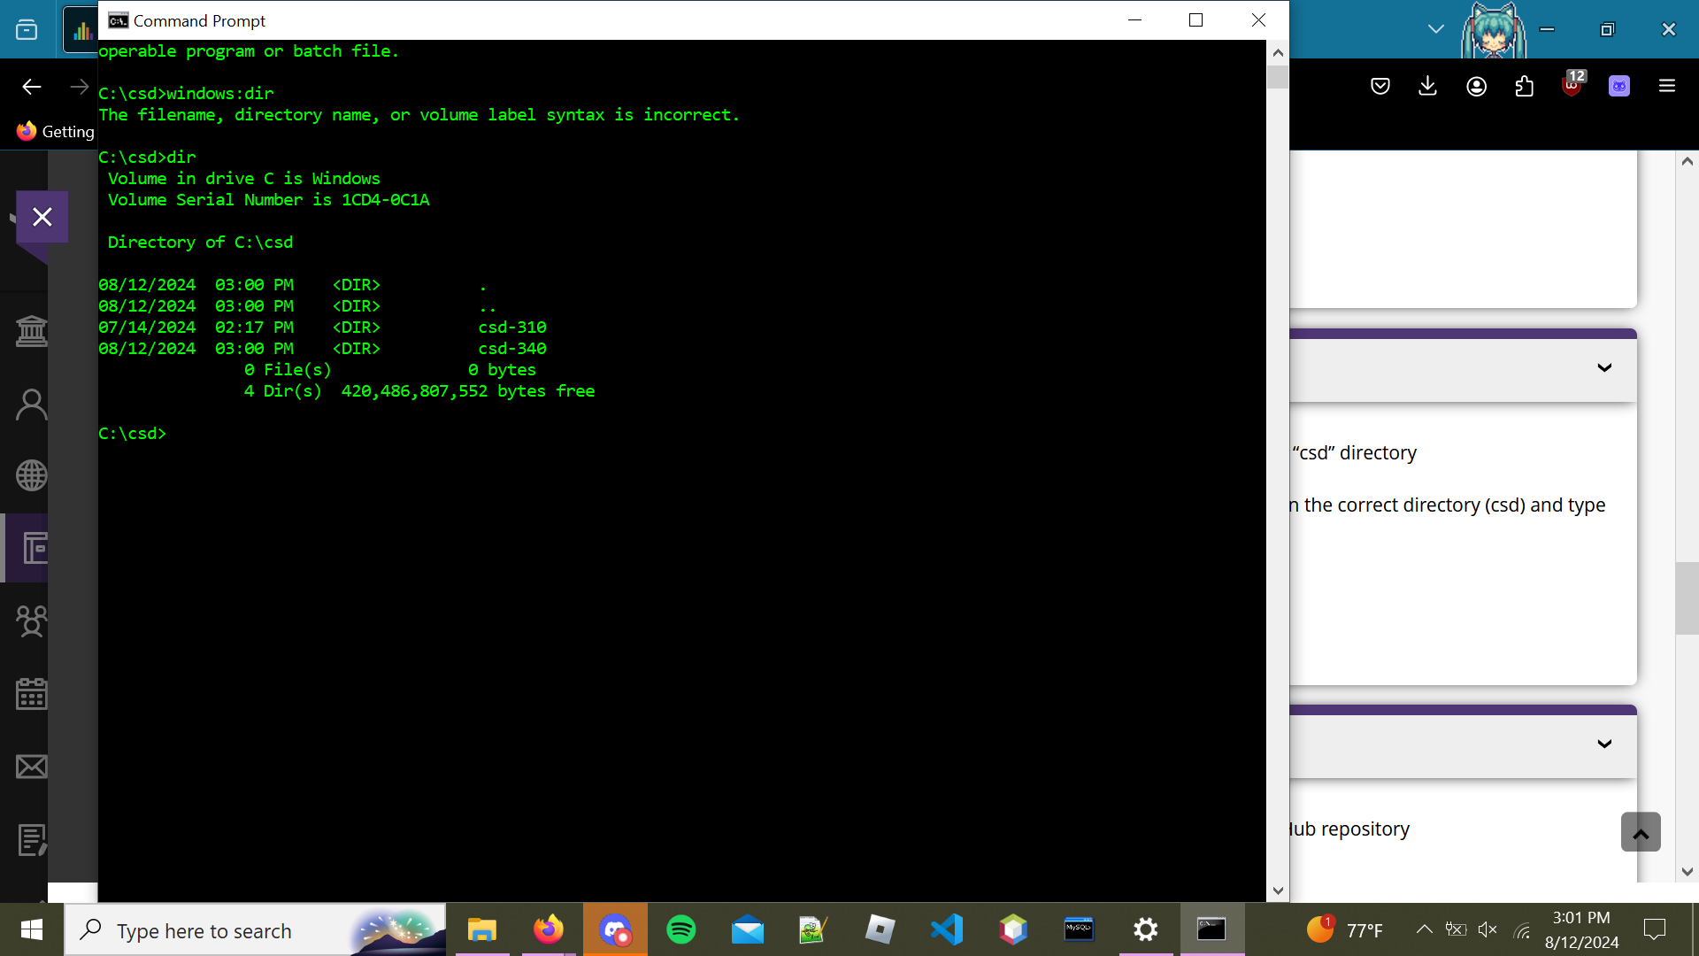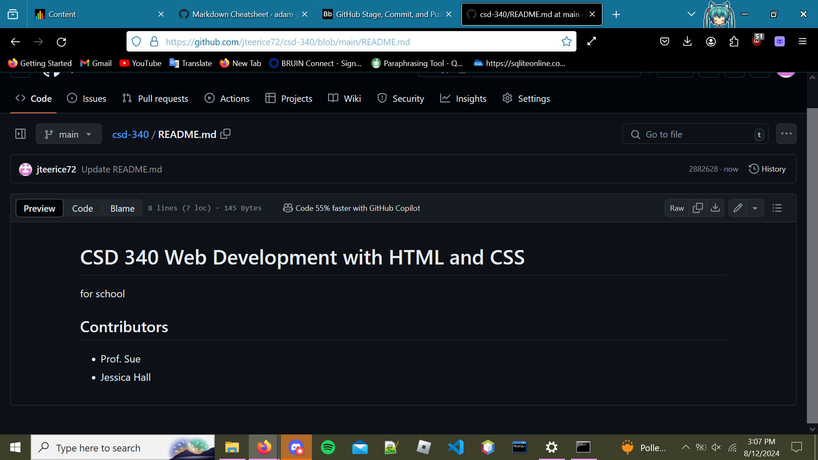https://github.com/jteerice72/csd-340.git